QR code - Spanish

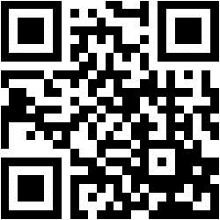

**SPANISH**



**SPANISH**



**SPANISH**

**SPANISH**

